**TVVS – Acceptance Tests Class**

Carolina Azevedo | Nelson Costa

(up201506509 | up201403128)

October 2nd 2019

**Exercise 1:**

Imagine you’re a software tester and you’re asked to write some acceptance tests for Booking.com website, considering these two user requirements:

1. User Login;
2. Book a room;

**Exercise 2 – Simple Calculator Testing:**

For this exercise, we’ll need to use an Acceptance Testing tool. We’re using Fitnesse.org, as presented in the class. To be able to use it fast, please follow the instructions:

1. On the command line, make sure you’re on the folder containing the provided tool file and execute it, using the command *java -jar fitnesse-standalone.jar -p <PortNumber>* 
   1. For the *PortNumber* aspect, you can type any, for example 2222.
2. On your browser, type [http://localhost:<portNumber](http://localhost:%3cportNumber)> and you’ll be redirected to our Fitnesse workspace.

As shown in the presentation, add more tests into the decision table, with support for power functions.

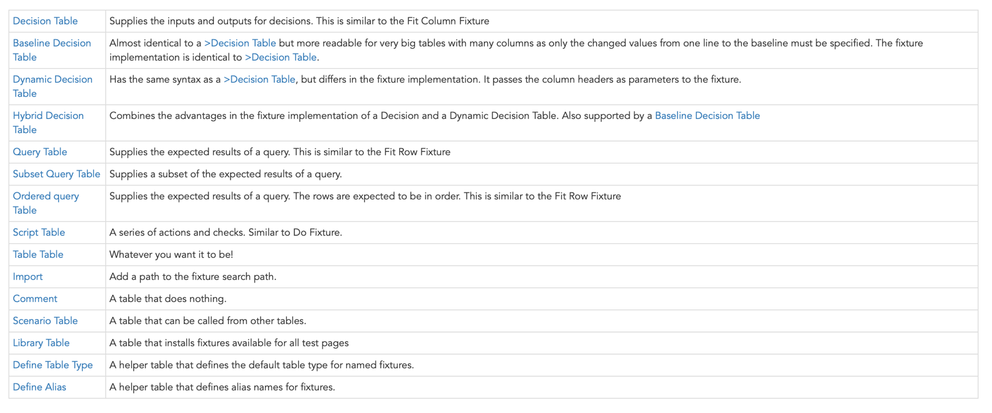**Exercise 3 – Social Network:**

Slim has a lot of tables, as you can see above.

Another quite useful is the Script Table, so, to get to know a little bit of them, we’re using a Social Network example:

|script | TVVS.SocialNetworkFixture |

|$SOCIALNETWORK = | getSocialNetwork() |

This tells the tool we want to build a script table, based on the class *SocialNetworkFixture* and create a new Social Network, to be saved into the variable *$*SOCIALNETWORK. Script tables are useful to do checks to some actions.

So, we want you to write the rows of script tables that answer to the following User Requirments:

* As an Admin, I want to check how many profiles my Social Network has, so that I can keep track of how popular it is.
* As a User, I want to create an account into the social network, so that I can start enjoying all its features.
* As a User, I want to see my information, so that I can check it.
* As a User, I want to create a post on to the social network, so that I can be an active member.